Dear Prime Minister Scott Morrison,

I am calling on you to free the people Australia has kept trapped on Nauru and Papua New Guinea for more than seven years.

There are options to get them to safety; the USA, Canada and Switzerland have already resettled many of these people. New Zealand is also willing to help.

Their situation is desperate. We need you to act before the death toll of 13 people who have been murdered or died in Australia’s offshore centres, grows even higher.

Please, act urgently and get these people to safety.

Yours sincerely,
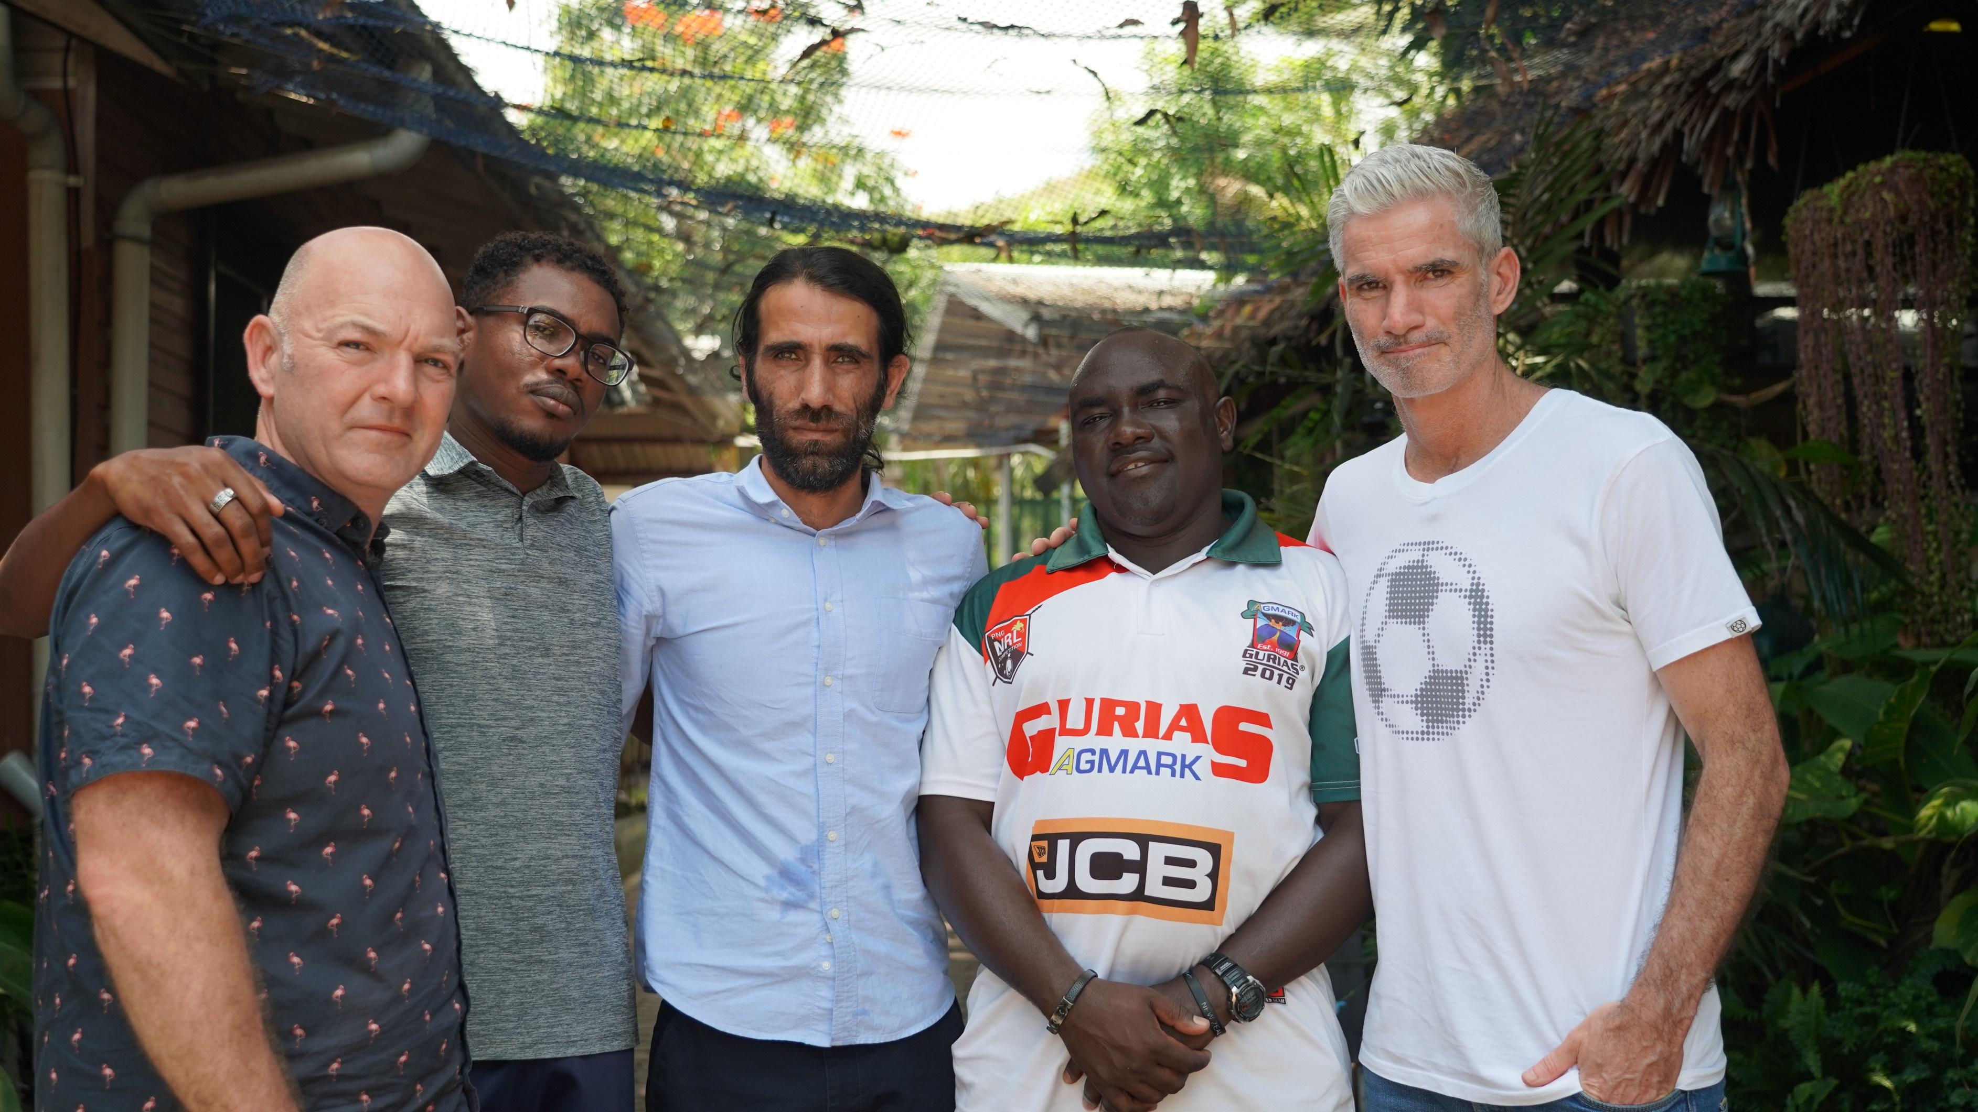

NAME | POSTCODE | SIGNATURE | EMAIL | MOBILE | DATE OF BIRTH
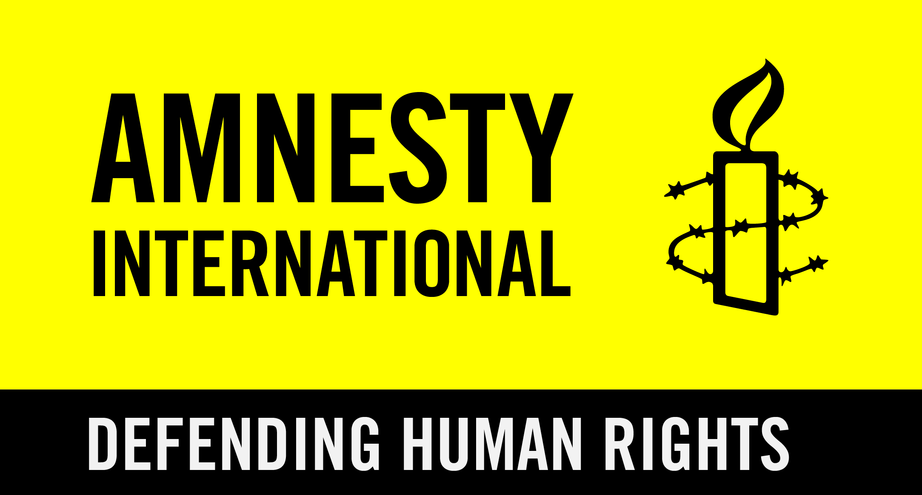
Published: 21/01/2020
All personal information you provide will be collected, stored and used in accordance with our privacy policy: www.amnesty.org.au/privacy.
We may use the information you provide to let you know about our campaigns and activities.

Return all petitions to your local Amnesty Action Centre or post to Locked Bag 23, Broadway NSW 2007, Australia

Tell us who collected this petition ______________________________ REF-1071

